Doug Strouth

CIS 228

City Jail Chapter 11

1)

SELECT AVG(COUNT(CRIME_ID))

FROM CRIME_OFFICERS

GROUP BY OFFICER_ID;

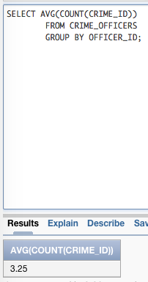

2)

SELECT COUNT(CRIME_ID), STATUS

FROM CRIMES

GROUP BY STATUS;

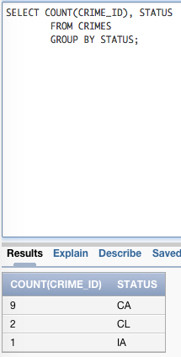

3)

SELECT MAX(COUNT(CRIME_ID)) "Most Crimes by One Person"

FROM CRIMES

GROUP BY CRIMINAL_ID;

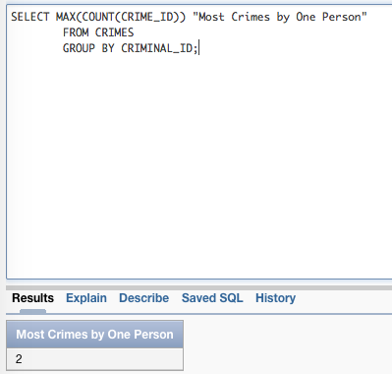

4)

SELECT MIN(FINE_AMOUNT) "Lowest Fine"

FROM CRIME_CHARGES;

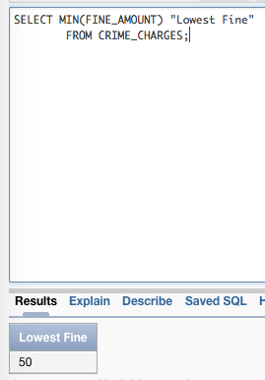

5)

SELECT CRIMINAL_ID,LAST, FIRST,COUNT(SENTENCE_ID)

FROM CRIMINALS JOIN SENTENCES USING(CRIMINAL_ID)

GROUP BY CRIMINAL_ID,LAST, FIRST

HAVING COUNT(SENTENCE_ID)>1;

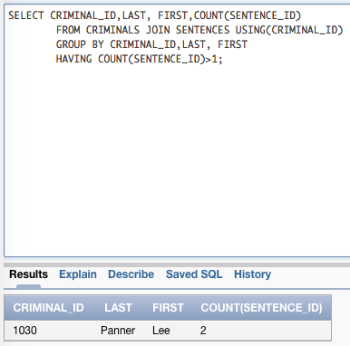

6)

SELECT PRECINCT,COUNT(CHARGE_STATUS)

FROM CRIME_CHARGES NATURAL JOIN CRIME_OFFICERS NATURAL JOIN OFFICERS

WHERE CHARGE_STATUS='GL'

GROUP BY PRECINCT

HAVING COUNT(CHARGE_STATUS)>7;

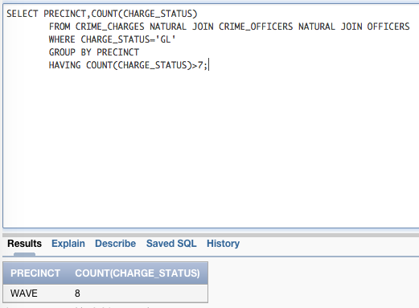

7)

SELECT CLASSIFICATION,TO_CHAR(SUM(FINE_AMOUNT+COURT_FEE),'$9,999.99') "Total Collections", TO_CHAR(SUM(FINE_AMOUNT+COURT_FEE-AMOUNT_PAID),'$9,999.99') "Amount Owed"

FROM CRIMES NATURAL JOIN CRIME_CHARGES

GROUP BY CLASSIFICATION;

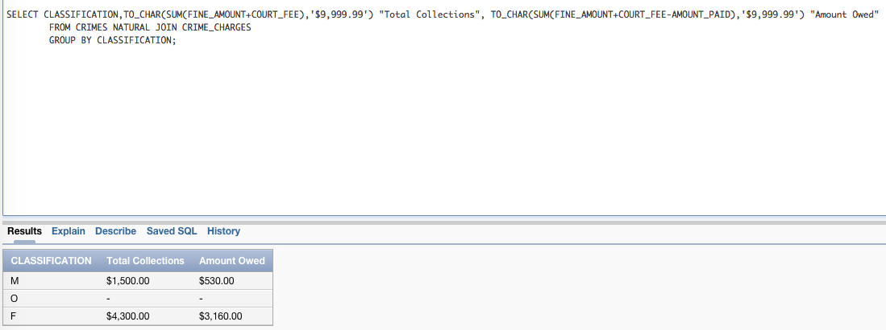

8)

SELECT CLASSIFICATION, CHARGE_STATUS, COUNT(CHARGE_ID) "Number of Charges"

FROM CRIMES NATURAL JOIN CRIME_CHARGES

GROUP BY ROLLUP (CLASSIFICATION,CHARGE_STATUS);

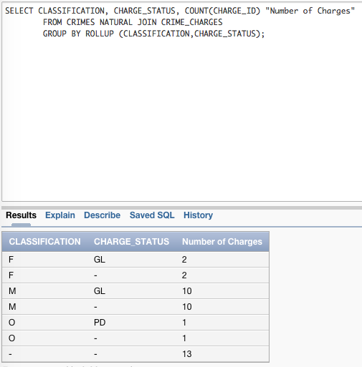

9a)

SELECT CLASSIFICATION, CHARGE_STATUS, COUNT(*)

FROM CRIMES NATURAL JOIN CRIME_CHARGES

GROUP BY GROUPING SETS ((CLASSIFICATION, CHARGE_STATUS), (CLASSIFICATION),(CHARGE_STATUS),());

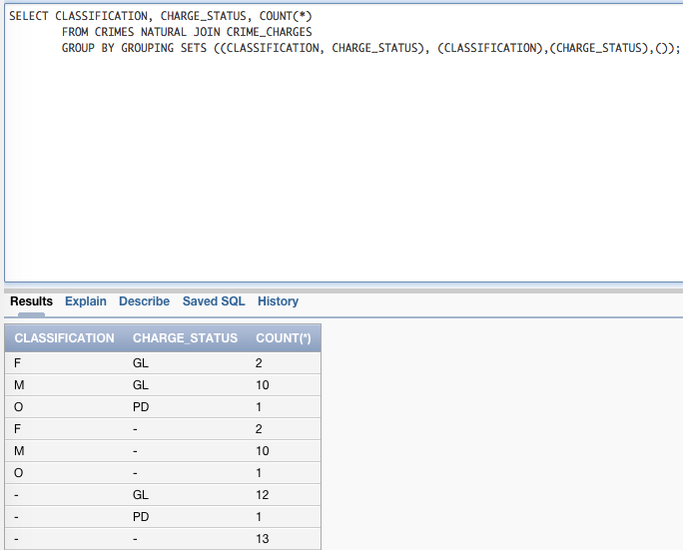

9b)

SELECT CLASSIFICATION, CHARGE_STATUS, COUNT(*)

FROM CRIMES NATURAL JOIN CRIME_CHARGES

GROUP BY CUBE (CHARGE_STATUS, CLASSIFICATION);

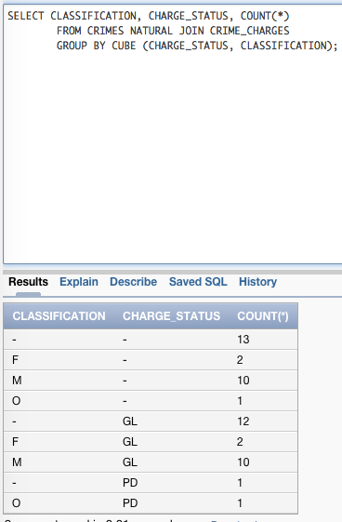

10a)

SELECT CLASSIFICATION, CHARGE_STATUS, COUNT(CHARGE_ID) "Number of Charges"

FROM CRIMES NATURAL JOIN CRIME_CHARGES

GROUP BY ROLLUP (CLASSIFICATION,CHARGE_STATUS);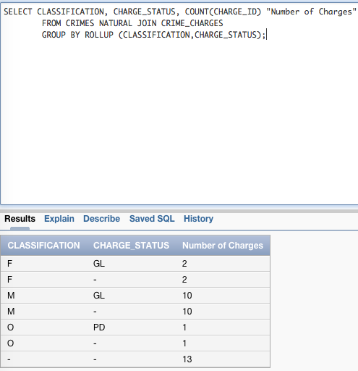

10b)   
SELECT CLASSIFICATION, CHARGE_STATUS, COUNT(*)

FROM CRIMES NATURAL JOIN CRIME_CHARGES

GROUP BY GROUPING SETS ((CLASSIFICATION, CHARGE_STATUS), (CLASSIFICATION), ());

